CS202: Data Structure - Fall 2025
Quiz 1 – Asymptotic Analysis
Time Limit: 10 minutes
Name: _____________________________________________________________________
Student ID: _________________________________________________________________

Q1) State the worst-case time complexity of the code below, in big-oh notation: [2.5 pts]
int func_y(vector<int>& a) {
int n = a.size();
for (int i = 0; i < n; i*=2) {
for (int j = i; j < n; j*=3) {
for (int k = 0; k < 20; k*=4) {
cout << k * (i - j) << endl;
}
}
}
return 0;
}

Q2) Sort the functions in increasing order of asymptotic (big-O) complexity: [2.5 pts]

Q3) (a) Express each function as the tightest Big-O upper bound. [5 pts]
 | Function | Tightest Big-Oh Upper Bound
1
2 | 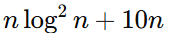
3
4
5 | 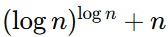

b) Complete the table below to state if each statement is True or False. [5 pts]

Expression No. | 1 | 2 | 3 | 4 | 5
True / False
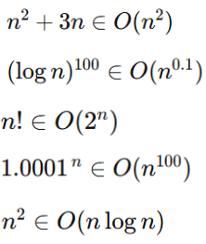
1.
2.
3.
4.
5.

